**SOFTWARE ENGINEERING**

**(IT-314)**

**EVENT PLANNER APPLICATION**

Deployment Plan

(Version 1.0)

**Team no: 14**

**Instructor: Prof. Asim Banerjee**

**Team Mentor: K. Hemantha**

**Date: 14 April, 2016**

**Team Members:**

|  |  |  |
| --- | --- | --- |
| **S.No** | **Name** | **ID** |
| 1. | Patel Yash | 201301008 |
| 2. | Patel Tej Naginbhai | 201301018 |
| 3. | Anavadiya Yash Kumar | 201301052 |
| 4. | Chauhan Dwimitra Dharmendra | 201301079 |
| 5. | Rahul Shashank Saranjame (Team Leader) | 201301101 |
| 6. | Fatnani Varun Kumarbhai | 201301152 |
| 7. | Nikita Jain | 201301155 |
| 8. | Karri Kiran Satish Reddy | 201301168 |
| 9. | Raman Kumar Douchaniya | 201301202 |

**Version History**

|  |  |  |
| --- | --- | --- |
| **Date** | **Version no.** | **Authors** |
| 14/04/2016 | 1.0 | Yash Patel, Dwimitra Chauhan |

**Table of Contents**

1. Introduction....................................................................................................4

1.1 Purpose.............................................................................................4

1.2 Scope……………............................................................................4

2. Deployment on local host...............................................................................4

2.1 Pre-installation requirement for wordpress......................................4

2.2 Installation………............................................................................4

1. **Introduction:**
   1. **Purpose:**

This document is guidance for our client so that he does not face any kind of difficulty for installing and deploying web application on local host. It will also guide about changes that are to be made on WordPress dashboard.

* 1. **Scope:**

The scope of this document is to make aware our client about installation and deploying web application.

1. **Deployment on local host:**
   1. **Pre-installation requirement for WordPress:**

Following are things that are needed to be installed by client:

* PHP 5.2.4 or higher (Download link: <http://php.net/downloads.php>)
* MySQL 5.0 or greater (Download link: <http://dev.mysql.com/downloads/mysql/5.0.html>)
* Download WordPress theme zerif-lite (Download link: https://wordpress.org/themes/zerif-lite)
  1. **Installation:**

Following instructions should be followed for launching XAMPP:

1. Download latest version of Xampp and install in your computer.

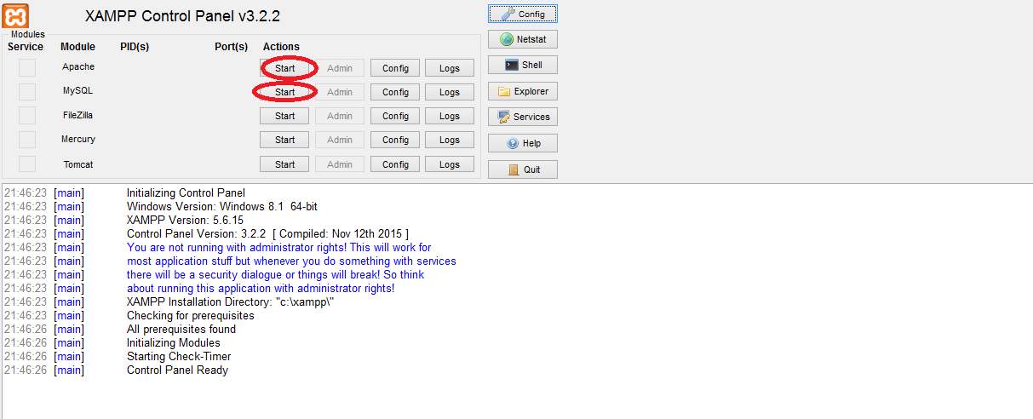

2). you will see xampp control panel. As marked in image launch apache and MySQL.

3). If there is problem in launching apache. As shown in image click on Apache (httpd.conf).

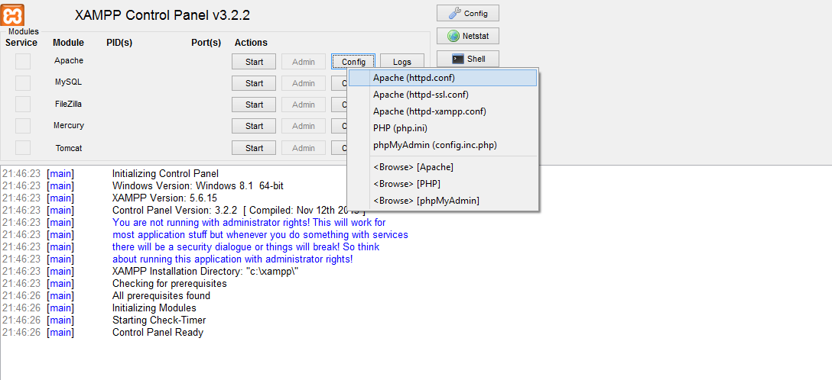

4). It will show text file. Change the value of variable ‘server name localhost’. Initially the value of variable is 80. Change the port number.

5). similarly, if there is problem in launching MYSQL then as shown in image click on ‘my.ini’.

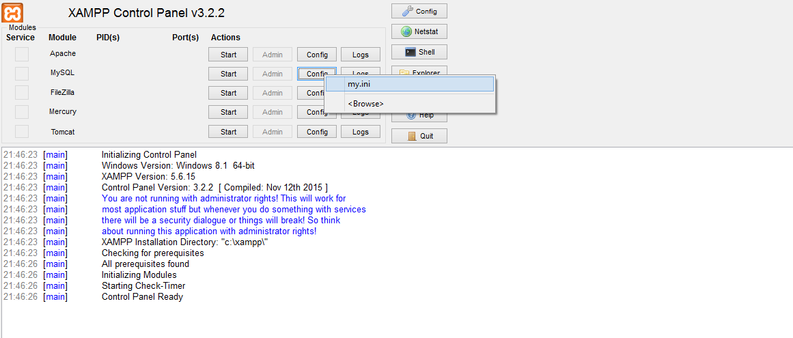

6). It will open a text file. In text file, the value of port is 3306. Change the value of port accordingly.

7.) Make the following changes in php.ini file located in the xampp folder in the C directory.

upload_max_filesize=1000M

memory_limit=1000M

post_max_size=1000M

SMTP=smtp.gmail.com

Smtp port=587

send_from=’noreplyaaa3@gmail.com’

8.) Install WordPress. Go to Appearances->Themes and import ZerifLite.

9.) Open localhost/phpmyadmin

10.) Click on New->enter sen in Create Database.

11.) Go to Database named sen and go to Import tab and choose sql file provided from there.